Retraite mentors-boursiers
2013
Mentor-Scholar Retreat

Vers / To Ryerson
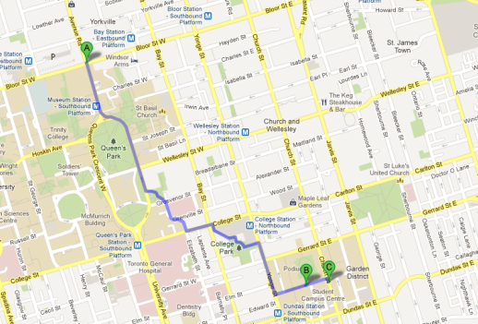
Distance 2,3 km. 27 min. à pied/by foot
Ryerson Image Centre
Sears Atrium
Park Hyatt Toronto
Park Hyatt Toronto
Ryerson Image Centre
Sears Atrium

A) Park Hyatt Toronto C) Sears Atrium
4 Avenue Road 245 Church Street
Toronto, ON M5R 2E8 Toronto, ON M5B 2K3

B) Ryerson Image Centre Pour urgence/Emergency contact 33 Gould Street Jennifer Petrela Toronto, ON M5B 2K3 petrela@fondationtrudeau.ca
Cell: 514-465-7233
Munk School of Global Affairs

