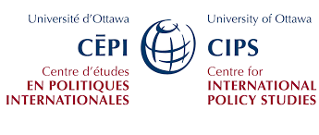
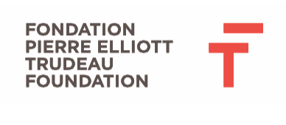

Canada’s Role in Democracy Promotion

A Pierre Elliott Trudeau Foundation Scholar Workshop,
in collaboration with the Centre for International Policy Studies, University of Ottawa

9:00 – 9:30 | Opening Words  - Morris Rosenberg, President & CEO, Pierre Elliott Trudeau Foundation  - Margaret Biggs, former president, Canadian International Development Agency (CIDA), Skelton-Clark Fellow School of Policy Studies and Department of Political Studies, Queens University  - Gabrielle Bardall, 2012 Pierre Elliott Trudeau Scholar, convener  - Stephanie Plante, Program Manager, CIPS
9:30 –11 | Panel 1.  International Democracy Promotion in the 21st Century: What’s been learned?  - Christopher Maclennan (moderator), ) Innovation Hub, Privy Council Office  - Thomas Carothers, Vice president for studies, Carnegie Endowment for International Peace  - Jean-Pierre Kingsley, former Chief Electoral Officer of Canada, former President & CEO, International Foundation for Electoral Systems  - Hélène Laverdière, MP for Laurier-Sainte Marie, NDP Critic for Foreign Affairs  - Leslie Campbell, Senior Associate and Regional Director for the Middle East and North Africa, National Democratic Institute
11 – 11:30 | Health break
11:30 – 1:00 | Panel 2.  Canada and Democracy in the World Today: Vision, Mandate & Expertise  - Eric Duhaime, journalist (moderator)  - Gerald Schmitz, independent academic & author  - Paul LaRose-Edwards, Executive Director, CANADEM  - Rupak Chattopadhyay, President, Forum of Federations  - Pamela Wallin, Senator

1:00 – 2:00 | Lunch
2:00 – 3:30 | Panel 3.  Ways Forward: Perspectives on Future Paths  - Gabrielle Bardall, 2012 Trudeau Scholar (moderator)  - Peter Kent, MP for Thornhill  - Arif Virani, MP for Parkdale-High Park  - Jean-Paul Ruszkowski, President and CEO, Parliamentary Centre  - Patricia Atkinson, former provincial MP, international expert
3:30 – 4:30 | Breakout Group Sessions  - Promoting Tolerance in a Sectarian Age, Thomas Axworthy, President and CEO, The Walter & Duncan Gordon Foundation, Member Pierre Elliott Trudeau Foundation  - Women and Political Participation, Althea-Maria Rivas, Senior Program Officer, Governance and Justice, International Development Research Centre  - Institutional Foundations for Sustainable Democracy, Helaina Gaspard, Senior Research Associate, Jean-Luc Pepin Research Chair, University of Ottawa  - Promoting Promotion: Prioritizing Democracy Amid Competing Demands, Honing Canadian Infrastructure. Stephen Brown, University of Ottawa  - Topic TBD, George Anderson, Senior mediation expert, United Nations' Mediation Support Unit, former President & CEO, Forum of Federations
4:30 – 5:00 | Group Debrief & Closing Remarks

